**DUNCTON PARISH COUNCIL**

**The Parish Council Meeting will be held on Monday 7th September 2020 at 7.00pm**

**In line with government guidelines this will be a Zoom meeting.**

**AGENDA**

1. Apologies for Absence
2. Code of Conduct

Declaration of Members’ disclosable pecuniary interests and other interests on items included on the Agenda.

1. Approval of Minutes of meeting held on 13 July
2. Update on matters carried forward from previous meeting:
3. Speeding – Cllr Thomas
4. Playground – Clerk & Cllrs Napthine & Clifford
5. Defibrillator – Cllrs O’Sullivan & Thomas
6. Website update - Clerk
7. Finance
8. To approve Clerks salary and expenses – **Appendix A**
9. To note and approve income and expenditure report **– Appendix B**
10. To approve the regularBank Reconciliation **– Appendix C**
11. District Councillors Report, to be submitted in advance – Alan Sutton – Chichester District Council
12. County Councillors Report, to be submitted in advance – David Bradford, West Sussex County Council
13. Planning – to update Council on any new/ongoing applications as applicable
14. Matters arising not dealt with on the Agenda
15. Public Questions (10 Minutes)
16. Any other matters for information only
17. Date of next Meeting – Monday 9th November 2020

Signed:

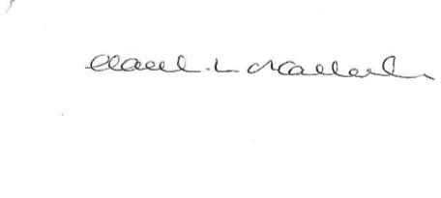

HL O’Callaghan

Clerk & RFO

**Appendix A**

**Clerk Salary and Expenses**

**Clerks Salary 1 – 31st July 2020**

Net Salary @£14.96 per hour £374

**Clerks Salary 1- 30th August 2020**

Net Salary @£14.96 per hour £374

**Paid by Standing Order on last working day of the month**

**Clerks Expenses August 2020**

|  |  |  |  |  |  |
| --- | --- | --- | --- | --- | --- |
| **Date Agreed** | **Detail** | **Reason** | **Cost ex VAT (£)** | **VAT (£)** | **Cost inc VAT (£)** |
| SO | Working from home allowance August | Paid prior to meeting as per contract. Agreed payment by dd each month | 36.00 | 0 | 36.00 |
|  |  |  |  |  |  |
| **Total** |  |  | **36.00** | **0** | **36.00** |

**Appendix B**



**Appendix C**

