**DUNCTON PARISH COUNCIL**

**The Parish Council Meeting will be held on Monday 9th November 2020 at 7.00pm**

**In line with government guidelines this will be a Zoom meeting.**

**AGENDA**

1. Apologies for Absence
2. Code of Conduct

Declaration of Members’ disclosable pecuniary interests and other interests on items included on the Agenda.

1. Approval of Minutes of meeting held on 7th September
2. Update on matters carried forward from previous meeting:
3. Speeding – Cllr Thomas
4. Playground – Clerk & Cllrs Napthine & Clifford
5. Defibrillator – Clerk & Cllrs O’Sullivan & Thomas
6. Finance
7. To approve Clerks salary and expenses – **attached**
8. To note and approve income and expenditure report **– attached**
9. To approve the regularBank Reconciliation **– attached**
10. To review budget in preparation for Precept setting
11. Planning Update
12. Rose Cottage SDNP/20/02550/HOUS
13. District Councillors Report, to be submitted in advance – Alan Sutton – Chichester District Council
14. County Councillors Report, to be submitted in advance – David Bradford, West Sussex County Council
15. Setting of dates for 2021 meetings – proposed dates (Mondays) 18th January, 15th March, 10th May, 12th July, 13th September, 8th November
16. Matters arising not dealt with on the Agenda
17. Public Questions (10 Minutes)
18. Any other matters for information only
19. Date of next Meeting – TBC

Signed:

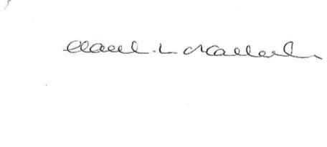

HL O’Callaghan

Clerk & RFO

**Appendix A**

**Clerk Salary and Expenses**

**Clerks Salary 1 – 30th September 2020**

Net Salary £367.30

PAYE £68.20

**Clerks Salary 1- 31st October 2020**

Net Salary £326.05

PAYE £58.20

**Paid by Standing Order on last working day of the month**

**Clerks Working from Home Expenses (as per contract)**

|  |  |  |  |  |  |
| --- | --- | --- | --- | --- | --- |
| **Date Agreed** | **Detail** | **Reason** | **Cost ex VAT (£)** | **VAT (£)** | **Cost inc VAT (£)** |
| 30/10/20 | Working from home allowance (October) | As per contract. Agreed payment by dd each month | 36.00 | 0 | 36.00 |
| **Total** |  |  | **36.00** | **0** | **36.00** |

**Appendix B**



**Appendix C**

