**DUNCTON PARISH COUNCIL**

**The Parish Council Meeting will be held on Monday 18 January 2021 at 7.00pm**

**In line with government guidelines this will be a Zoom meeting.**

**AGENDA**

1. Apologies for Absence
2. Code of Conduct

Declaration of Members’ disclosable pecuniary interests and other interests on items included on the Agenda.

1. Approval of Minutes of meeting held on 9th November 2020
2. Update on matters carried forward from previous meeting:
3. Speeding – Cllr Thomas
4. Playground – Clerk & Cllrs Napthine & Clifford
5. Footpaths – Cllr Thomas/Cllr Clifford
6. Finance
7. To approve Clerks salary and expenses – **Attached Appendix A**
8. To note and approve income and expenditure report **– Attached Appendix B**
9. To approve the regularBank Reconciliation **Attached Appendix C**
10. To review budget in preparation for Precept setting – **Attached**
11. Planning Update
12. Rewilding of communal areas
13. Barlavington Estate Plan
14. District Councillors Report, to be submitted in advance – Alan Sutton – Chichester District Council
15. County Councillors Report, to be submitted in advance – David Bradford, West Sussex County Council
16. Matters arising not dealt with on the Agenda
17. Public Questions (10 Minutes)
18. Any other matters for information only
19. Date of next Meeting – 15th March 2021
20. Exclusion of Press and Public
21. Consideration of Clerk pay review to SCP 26 in line with contracted yearly pay review

Signed:

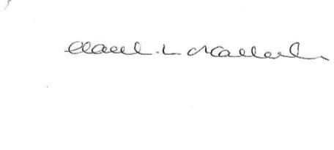

HL O’Callaghan

Clerk & RFO

**Appendix A**

**Clerk Salary and Expenses**

**Clerks Salary 1 – 30th November 2020**

Net Salary £326.25

PAYE £58.20

**Clerks Salary 1- 31st December 2020**

Net Salary £326.25

PAYE £58.00

**Paid by Standing Order on last working day of the month**

**Clerks Working from Home Expenses (as per contract)**

|  |  |  |  |  |  |
| --- | --- | --- | --- | --- | --- |
| **Date Paid** | **Detail** | **Reason** | **Cost ex VAT (£)** | **VAT (£)** | **Cost inc VAT (£)** |
| 31/12/20 | Working from home allowance (December) | As per contract. Agreed payment by dd each month | 36.00 | 0 | 36.00 |
| **Total** |  |  | **36.00** | **0** | **36.00** |

**Appendix B**



**Appendix C**

